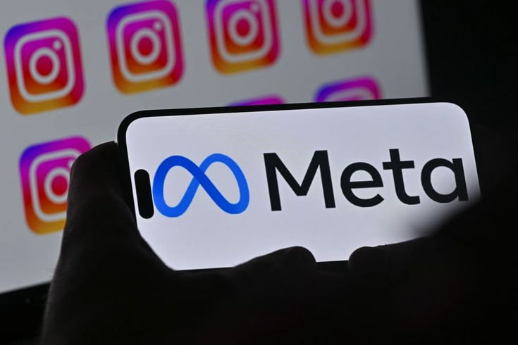

SQL: Social Media Project

By: VIKRANT RAJPUT

Objective Questions

Q1. Are there any tables with duplicate or missing null values? If so, how would you handle them?

Ans. The dataset is well-structured with PRIMARY KEY and NOT NULL constraints, minimizing duplicates and missing values. But I generated a query using the GROUP BY clause to group all rows by the target column(s) i.e. the column(s) you want to check for duplicate and null values on.
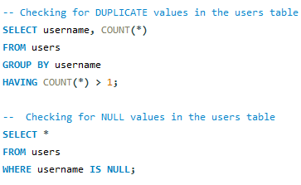

Q2. What is the distribution of user activity levels (e.g., number of posts, likes, comments) across the user base?

Ans. To analyze user engagement on the platform, user activity was evaluated based on three key metrics: the number of posts created, likes given, and comments made by each user. First, these activity metrics were calculated for every user by joining the users, photos, likes, and comments tables. A LEFT JOIN was used to ensure that even users with no activity were included in the analysis.

Next, users were categorized into different activity levels using conditional logic:

- Inactive: Users with zero posts, likes, and comments
- Low Activity: Users with minimal engagement (few posts, likes, and comments)
- Medium Activity: Users with moderate engagement across any of the activity metrics
- High Activity: Users with high engagement in terms of posting, liking, or commenting

Finally, the distribution of users across these activity levels was calculated by grouping users based on their assigned category.

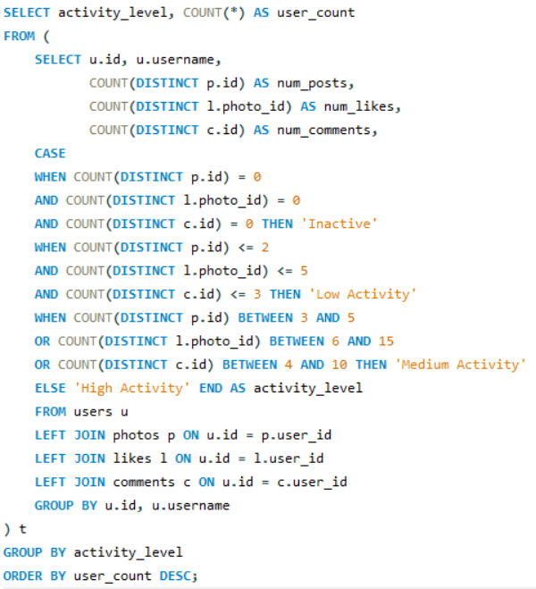

And the output of the query is like this.

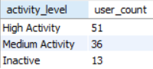

Q3. Calculate the average number of tags per post (photo_tags and photos tables).

Ans. The average number of tags per post was calculated by counting tags for each photo and taking the average across all posts using a LEFT JOIN. Also used ROUND() function in query to make output clean and the result shows that each post has approximately 1.95 tags on average.

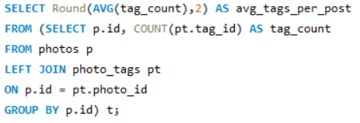
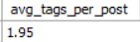

Q4. Identify the top users with the highest engagement rates (likes, comments) on their posts and rank them.

Ans. User engagement was calculated by counting the total likes and comments received on each user’s posts. These values were combined to compute overall engagement for every user. Finally, users were ranked based on total engagement to identify the top-performing users.

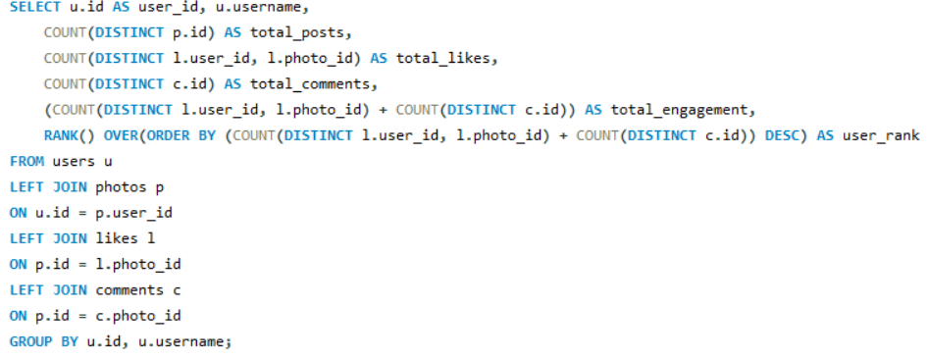

Giving us the output like this and so on.

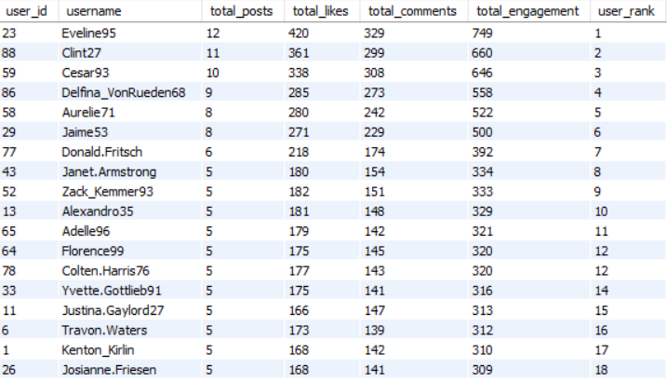

Q5. Which users have the highest number of followers and followings?

Ans. The number of followers and followings for each user was calculated using the follows table. Followers were counted based on followee_id, while followings were counted using follower_id. Users were ordered in descending order of followers and followings to highlight the most connected and influential users on the platform.

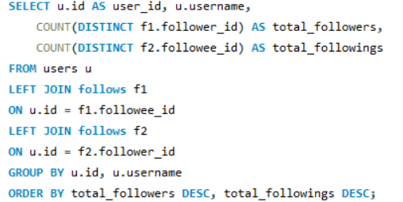

Giving us the output like this and so on.

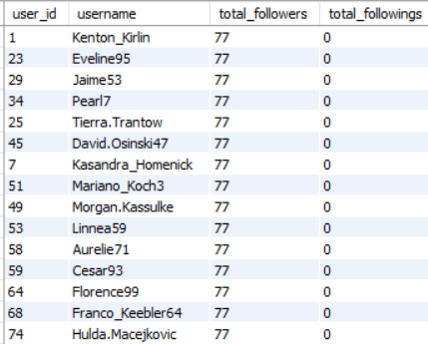

Q6. Calculate the average engagement rate (likes, comments) per post for each user.
Ans. To calculate the average engagement per post for each user, in the query, I first counted the total number of posts created by the user and then calculated the total likes and comments received on those posts. The engagement rate was obtained by dividing the total engagement (likes + comments) by the total number of posts. I also included the total number of followers for each user by using the follows table. This provides a better understanding of not only how much engagement a user receives but also how large their audience is.
I used LEFT JOIN so that every user is included in the result, even if they have no posts or followers. The NULLIF() function was used to avoid division-by-zero errors, so users who have not posted any content will have a NULL engagement rate. Finally, the engagement rate was rounded to two decimal places to make the output easier to read.

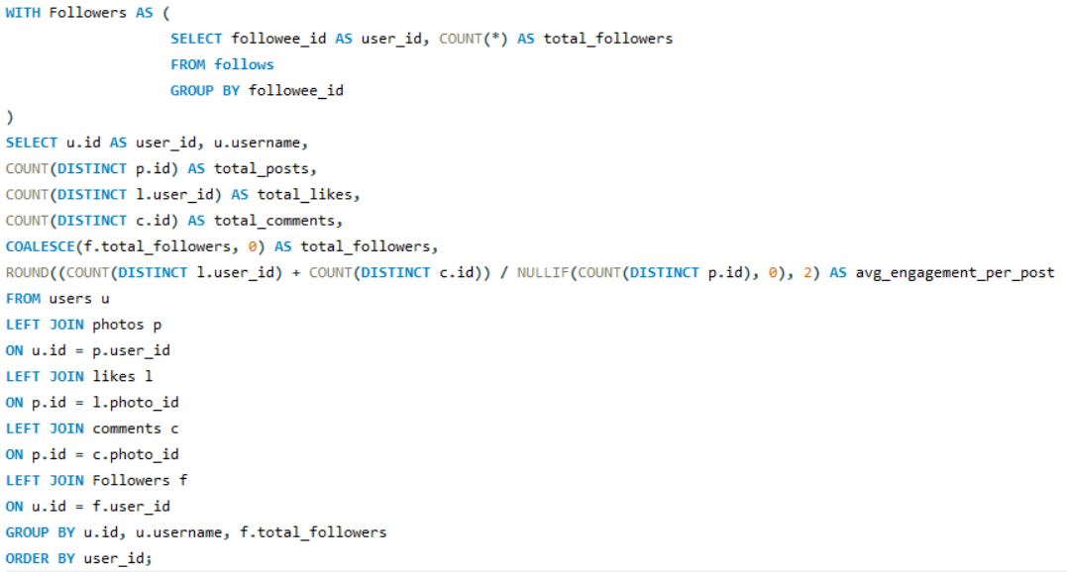

The final output displays each user's total posts, total likes received, total comments received, total followers, and average engagement per post, helping identify users who have both strong engagement and a large follower base.
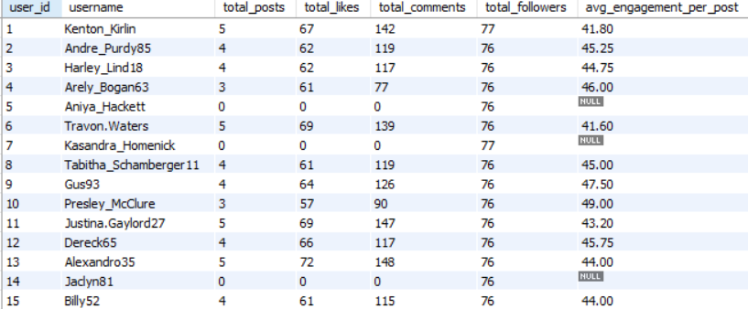

Q7. Get the list of users who have never liked any post (users and likes tables)

Ans.

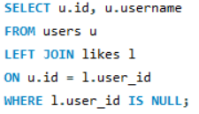

This query retrieves the list of users who have never liked any post. It starts with the users table and performs a LEFT JOIN with the likes table using the user_id column. A LEFT JOIN returns all users, including those who do not have matching records in the likes table. The WHERE l.user_id IS NULL condition filters only those users for whom no matching like record exists, resulting in the list of users who have never liked any post.

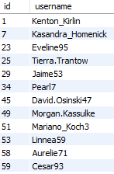

Q8. How can you leverage user-generated content (posts, hashtags, photo tags) to create more personalised and engaging ad campaigns?

Ans.

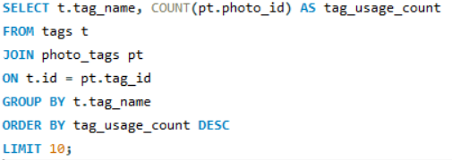

This query counts how many times each hashtag has been used across all photos in the dataset. It joins the tags and photo_tags tables to connect each hashtag with the photos where it appears. The data is then grouped by hashtag name and sorted in descending order of usage count, making it easy to identify the most frequently used hashtags. The final output highlights trending hashtags, which can help understand user interests and can be used to create more personalized and engaging advertising campaigns.

Thus, giving the output like this

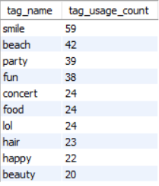

Insights :

- #smile is the most frequently used hashtag (59), indicating that users commonly share positive and expressive content.

- #beach (42), #party (39), and #fun (38) are also among the most popular hashtags, showing strong interest in lifestyle and recreational content.

- Several hashtags such as #concert, #food, and #lol have similar usage counts, suggesting that users engage with a variety of content categories.

- Popular hashtags can be leveraged in personalized ad campaigns and content recommendations to improve user engagement and campaign reach.

Q9. Are there any correlations between user activity levels and specific content types (e.g., photos, videos, reels)? How can this information guide content creation and curation strategies?

Ans. Since the available dataset contains only photo-based posts, the analysis is limited to photo content. The user activity distribution shows that most users are actively engaging with the platform, with 51 users classified as Highly Active, 36 as Moderately Active, and 13 as Inactive. This indicates that a large portion of users regularly interact with content, while a smaller group presents an opportunity for re-engagement.
These insights can help guide content creation by encouraging consistent posting and promoting content that receives higher engagement. Personalized recommendations, trending hashtags, and targeted campaigns can be used to increase user activity and improve overall engagement. If data for videos and reels were available, the same analysis could be extended to compare engagement across different content types and further optimize content curation strategies.

Note: The above visualization is based on the user activity segmentation performed in Subjective Question 6, where users were classified into Highly Active, Moderately Active, and Inactive categories based on their posting activity, likes, and comments. The same results have been summarized to understand the overall distribution of user activity levels and their impact on engagement.

Chart Insights :
• 51% of users are Highly Active, showing strong participation on the platform.
• 36% of users are Moderately Active, representing users who can be encouraged to engage more frequently.
• Only 13% of users are Inactive, making them suitable targets for re-engagement campaigns.
• The activity distribution indicates that consistent user participation is closely associated with higher engagement on the platform.

Q10. Calculate the total number of likes, comments, and photo tags for each user.
Ans. The total number of likes, comments, and photo tags for each user was calculated by joining the users table with photos and related interaction tables. Engagement metrics were aggregated based on each user’s posts. This provides a complete view of user activity and content interaction.
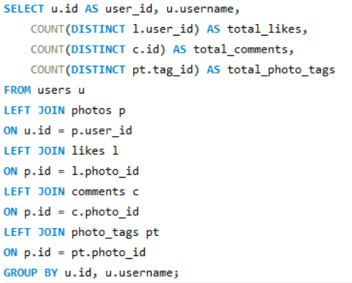

This is giving me the following output like this, and so on.

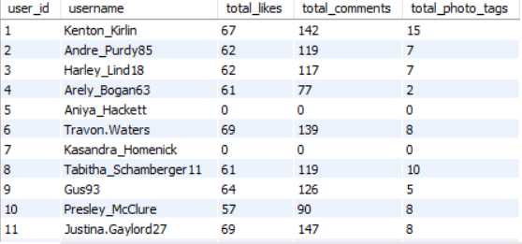

Q11. Rank users based on their total engagement (likes, comments, shares) over a month.

Ans. Ranking Users Based on Monthly Engagement

- To measure user performance, total engagement was calculated by counting the likes and comments received on each user’s posts within a specific month (i.e June).

- This was done by filtering engagement data based on the month and then aggregating it for each user.

- Users were then ranked in descending order of their total engagement to identify the most active and influential users during that period.

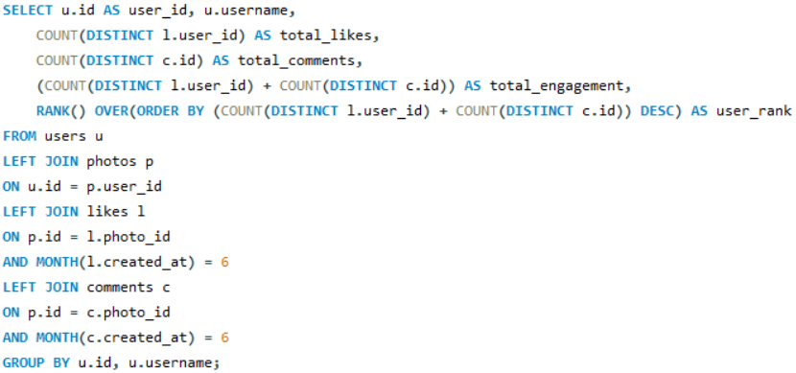

The desired output helps in understanding which users generate the most interaction and can be useful for identifying top content creators on the platform.

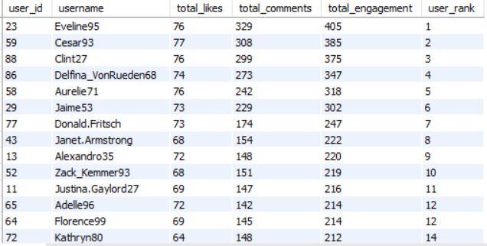

Q12. Retrieve the hashtags that have been used in posts with the highest average number of likes. Use a CTE to calculate the average likes for each hashtag first.

Ans. Hashtags with Highest Average Likes

• To retrieve the hashtags with the highest average number of likes, I used two CTEs. In the first CTE, I calculated the total number of likes and total number of posts associated with each hashtag. In the second CTE, I used these values to compute the average number of likes per post for each hashtag.

• In the final query, I sorted the hashtags based on their average likes and selected the top 5 hashtags with the highest average engagement using the LIMIT clause.
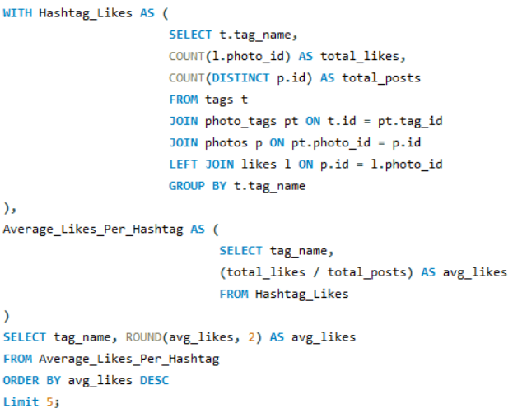

This query gave the following desired output, and I use a Column Chart also for proper visibility.

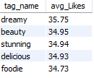

Q13. Retrieve the users who have started following someone after being followed by that person.

Ans. In this question in order to retrieve the users who have started following someone after being followed by that person I employed a Query where I used the created_at column to compare the followee_id and follower_id whichever was created before.

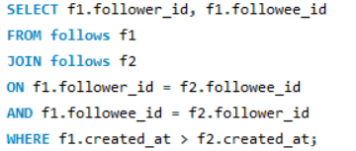

The output is blank because we didn’t find any such record proving there is no such kind of users.

Subjective Questions

Q1. Based on user engagement and activity levels, which users would you consider the most loyal or valuable? How would you reward or incentivize these users?

Ans 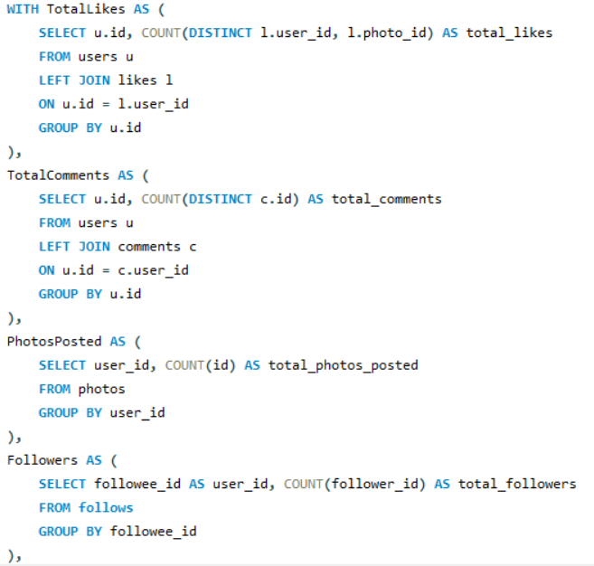 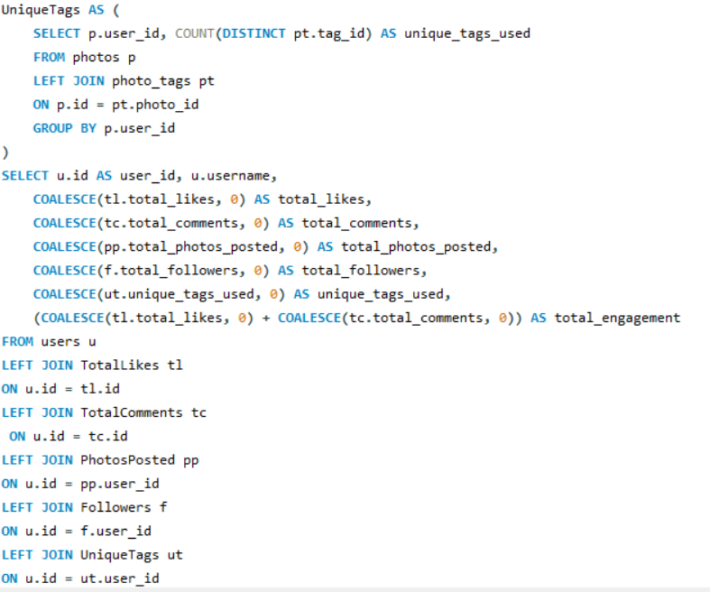 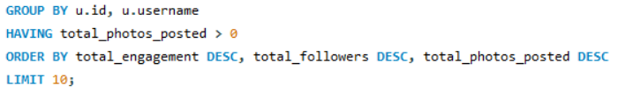

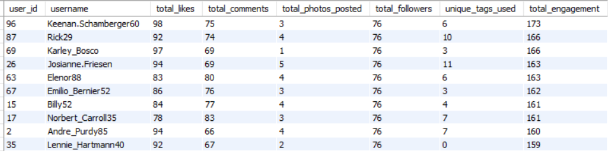

INSIGHTS
• Top Contributors Identified: After analyzing the data, it was clear that a small group of users consistently stay active on the platform through posting, liking, and commenting. These users can be considered the top contributors.
• High Engagement Shows Loyalty: Users who receive more likes and comments are generally more engaged, which indicates that they are more loyal and interested in the platform.
• Likes and Comments Activity: Most of the user activity comes from likes and comments rather than just posting content, showing that interaction plays a bigger role in engagement.
• Consistency Matters More Than One-Time Activity: Users who are regularly active over time are more valuable compared to those who show high activity only once. Consistency is a key factor in identifying loyal users.

RECOMMENDATIONS
• Reward Loyal Users: The platform can introduce rewards like badges, leaderboards, or special access to features for highly active users to keep them motivated.
• Encourage More Interaction: Features like likes and comments can be promoted using simple gamification ideas so that less active users also start participating more.
• Track User Behavior Regularly: Keeping an eye on user activity trends can help identify new active users early and keep them engaged.
• Segment Users Smartly: Users can be divided into different groups based on their activity level, and personalized content or rewards can be given to each group.
• Improve Community Features: Adding or improving features like replies, mentions, or discussions can help users interact more and feel more connected to the platform.

Q2. For inactive users, what strategies would you recommend to re-engage them and encourage them to start posting or engaging again?

Ans. Re-engaging inactive users requires understanding their behavior and providing them with reasons to return to the platform. A personalized approach can make users feel more connected by recommending content based on their previous interests, favorite hashtags, or past interactions. Sending timely notifications, emails, or reminders about trending posts and new activities can also encourage users to revisit the platform.
In addition, introducing rewards such as badges, exclusive features, posting challenges, or limited-time incentives can motivate users to start interacting again. Improving content recommendations, highlighting popular posts, and creating a simple and engaging user experience can further increase user participation. By combining personalization, incentives, and continuous engagement strategies, Instagram can effectively improve user retention and encourage inactive users to become active members of the platform again.
Re-engagement Strategy Diagram for Inactive Users :
Inactive Users
↓
Personalized Notifications
↓
Relevant Content Recommendations
↓
Rewards & Posting Challenges
↓
Higher User Engagement
↓
Active Users

Insights :
• Personalized notifications can encourage inactive users to revisit the platform.
• Showing relevant and trending content increases the chances of user interaction.
• Rewards and gamification features motivate users to post and engage more frequently.
• A better user experience and personalized recommendations help improve long-term user retention.

Recommendations :
• Send personalized notifications based on users' previous interests.
• Recommend trending posts, hashtags, and creators relevant to each user.
• Introduce rewards, badges, and posting challenges to encourage participation.
• Run re-engagement campaigns targeting inactive users through emails and app notifications.
• Continuously monitor user activity and refine engagement strategies based on user behavior.

Q3. Which hashtags or content topics have the highest engagement rates? How can this information guide content strategy and ad campaigns?

Ans.

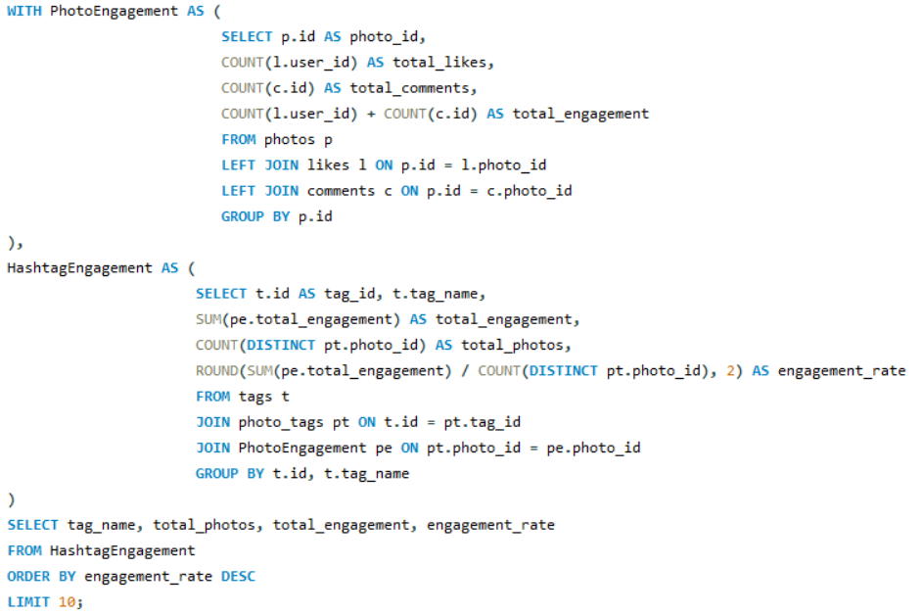

Explanation of Hashtag Engagement Query

• In this query, the first step is to calculate engagement for each photo. This is done by counting the number of likes and comments on every photo and then combining them to get the total engagement per photo.
• In the second step, this photo-level engagement is connected with hashtags using the photo_tags table. This helps in understanding how much engagement each hashtag is generating across all the photos where it is used.
• For each hashtag, the total engagement is calculated by summing up engagement from all related photos. At the same time, the total number of posts using that hashtag is also counted.
• Using these values, the engagement rate is calculated as the average engagement per post for each hashtag.
• Finally, the hashtags are sorted based on their engagement rate in descending order, and the top 10 hashtags with the highest engagement are selected.
• This helps in identifying which hashtags are most effective in generating user interaction on the platform.

And the output of the query is like this

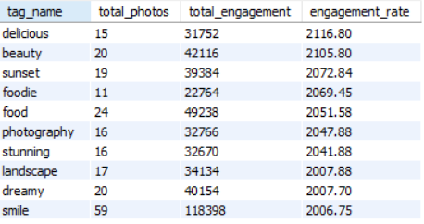

INSIGHTS:

• Top Performing Hashtags Identified: Hashtags like delicious, beauty, sunset, foodie, and food have the highest engagement rates, indicating that these topics are highly popular among users.

• Content Themes Matter: Most high-performing hashtags are related to lifestyle, food, and visual content, suggesting that users are more attracted to visually appealing and relatable topics.

• High Engagement ≠ High Usage: Some hashtags with fewer posts (e.g., delicious, foodie) still have very high engagement rates, showing that quality and relevance of content matter more than quantity.

• Popular Tags Drive Interaction: Hashtags like smile and food have a high number of posts along with strong engagement, making them reliable choices for consistent interaction.

RECOMMENDATIONS:
• Focus on High-Engagement Topics: Content creators should prioritize hashtags like food, beauty, travel, and lifestyle to increase visibility and engagement.
• Balance Quality and Quantity: Instead of just increasing the number of posts, focus on creating high-quality content that aligns with trending hashtags.
• Use Relevant Hashtags Strategically: Including high-performing hashtags in posts can improve reach and attract more user interaction.
• Leverage for Ad Campaigns: Brands can design campaigns around these popular topics to target audiences more effectively and improve campaign performance.

Q4. Are there any patterns or trends in user engagement based on demographics (age, location, gender) or posting times? How can these insights inform targeted marketing campaigns?

Ans.
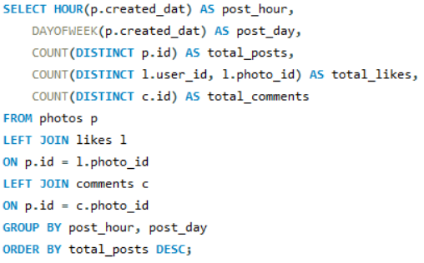
This query analyzes user engagement based on posting time by extracting the hour and day from when each post was created. It calculates the total number of posts along with the number of likes and comments received in each time slot. The use of LEFT JOIN ensures that even posts with no engagement are included in the analysis. Finally, the data is grouped and sorted to identify the most active posting times and their corresponding engagement levels.
And, the output is looking like this

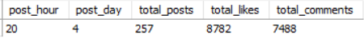

INSIGHTS:
• Peak Engagement Time Identified: The highest user activity and engagement occur around 8 PM, indicating that users are most active during evening hours.
• Mid-Week Activity Spike: Day 4 (Wednesday) shows the highest number of posts and interactions, suggesting that engagement is stronger during mid-week compared to other days.
• Higher Activity = Higher Engagement: The time slot with the highest number of posts also receives the most likes and comments, showing a direct relationship between posting activity and engagement.
RECOMMENDATIONS:
• Post During Peak Hours: Content should be scheduled around evening time (especially around 8 PM) to maximize visibility and engagement.
• Leverage Mid-Week Engagement: Brands and creators should focus more on posting during mid-week, especially on Wednesdays, to reach a more active audience.
• Optimize Campaign Timing: Ad campaigns and promotional content should be launched during these high-engagement periods to improve performance and user interaction.
• Maintain Consistency: Regular posting during peak times can help in building stronger audience engagement and improving overall reach.

Q5. Based on follower counts and engagement rates, which users would be ideal candidates for influencer marketing campaigns? How would you approach and collaborate with these influencers?

Ans.

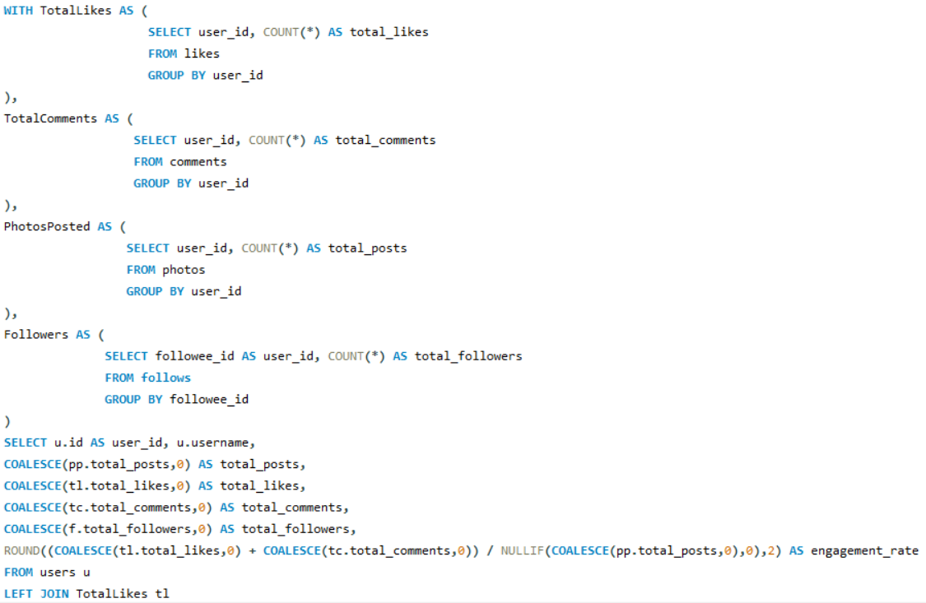
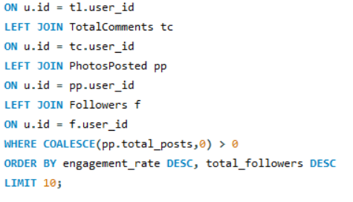
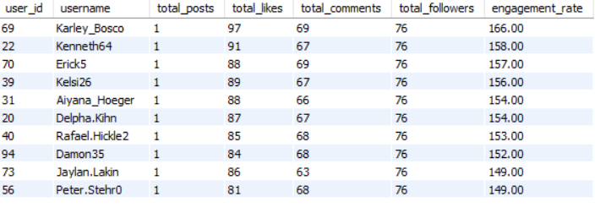

INSIGHTS
a) High-Value Users Identified: The analysis helped identify the top users who have both a strong follower base and high engagement rates. These users are likely to have a greater influence on their audience and are suitable candidates for influencer marketing campaigns.
b) Engagement Matters More Than Followers Alone: While a large follower count increases reach, users with consistently high likes and comments demonstrate stronger audience interaction. This makes engagement rate an important factor when selecting influencers.
c) Consistent Activity Builds Influence: Users who post regularly and maintain steady engagement are more reliable for brand collaborations. Consistent activity helps them build trust and long-term relationships with their followers.

RECOMMENDATIONS
a) Collaborate with the Right Influencers: Select users who have a healthy combination of high engagement, regular posting, and a strong follower base, ensuring that their content aligns with the brand's target audience.
b) Build Authentic Partnerships: Instead of focusing only on one-time sponsored posts, create long-term collaborations through brand ambassador programs, product launches, or exclusive campaigns to build trust with their audience.
c) Leverage Micro-Influencers: Along with popular influencers, consider collaborating with micro-influencers who have smaller but highly engaged communities, as they often generate better audience interaction and credibility.
d) Measure Campaign Performance: Track campaign success using engagement metrics such as likes, comments, shares, and conversions to understand which collaborations deliver the best results and optimize future campaigns.
e) Maintain an Influencer List: Regularly update a list of high-performing influencers based on their engagement trends and follower growth. This makes it easier to identify suitable partners for future marketing campaigns.

Q6. Based on user behaviour and engagement data, how would you segment the user base for targeted marketing campaigns or personalized recommendations?

Ans.

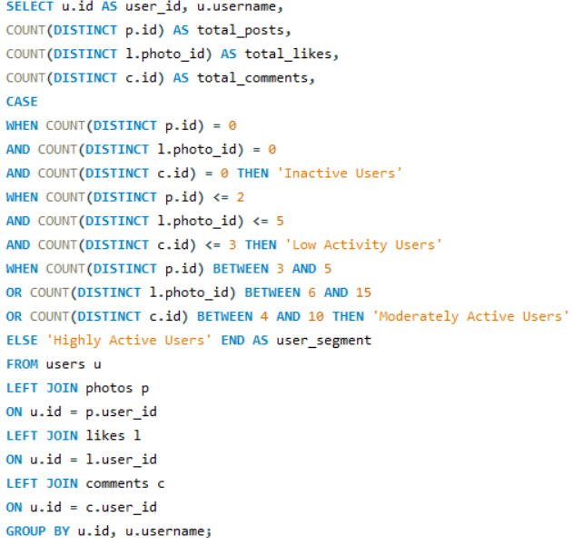
This query segments users based on their activity levels by analyzing three key metrics: number of posts, likes, and comments. It counts each user’s total posts, likes, and comments using LEFT JOIN to ensure even inactive users are included.
Based on these counts, users are categorized into different groups, such as Inactive, Low Activity, Moderately Active, and Highly Active, using a CASE statement. This classification helps in understanding how actively users interact with the platform.

And the output is looking like this

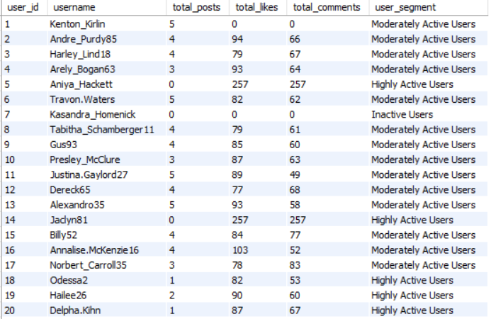

INSIGHTS:

• Clear User Segmentation: Users are effectively divided into different activity levels, making it easy to identify highly engaged users as well as inactive ones.

• Majority Behavior Identification: Most users typically fall into low or moderate activity segments, indicating opportunities to increase engagement.

• Highly Active Users are Key Assets: Users in the high activity segment contribute the most in terms of content creation and interactions.

• Inactive Users Exist: A portion of users shows no activity, indicating potential drop-offs or lack of engagement.

RECOMMENDATIONS:
• Target Highly Active Users: Provide rewards, exclusive features, or recognition to retain and motivate these users.
• Engage Moderate Users: Encourage them to become more active through personalized recommendations, notifications, and incentives.
• Re-activate Low/Inactive Users: Use strategies like email campaigns, trending content, or onboarding reminders to bring them back.
• Personalized Marketing: Use these segments to run targeted campaigns based on user behavior and activity level.
• Improve Platform Engagement: Focus on features that promote interaction, such as comments, likes, and content sharing.

Q7. If data on ad campaigns (impressions, clicks, conversions) is available, how would you measure their effectiveness and optimize future campaigns?

Ans. Measuring Ad Campaign Effectiveness & Optimization Strategy

• To measure the effectiveness of ad campaigns, key metrics such as impressions, clicks, and conversions should be analyzed. Impressions indicate how many times the ad was shown, clicks show user interest, and conversions reflect the actual desired action (such as purchase or sign-up).

• One of the most important metrics is the Click-Through Rate (CTR), which is calculated as clicks divided by impressions. A higher CTR indicates that the ad is relevant and engaging to users.

• Another key metric is the Conversion Rate, calculated as conversions divided by clicks. This helps in understanding how effectively the ad turns user interest into actual results.

• Additionally, Cost per Conversion and Return on Investment (ROI) can be used to evaluate the financial performance of campaigns and determine whether the campaign is profitable.

Optimizing Future Campaigns

• A/B Testing: Test different versions of ads (headlines, images, call-to-actions) to identify what performs best and use those insights to improve future campaigns.

• Refining Targeting: Analyze which audience segments respond better and focus campaigns on high-performing groups to improve efficiency and results.
• Platform Optimization: Identify which platforms, placements, or time slots generate the best engagement and allocate more budget to those areas.

• Retargeting Strategy: Target users who have previously interacted with the brand but did not convert, using personalized ads to encourage completion of actions.

• Continuous Monitoring: Regularly track campaign performance and make data-driven adjustments to improve outcomes over time.

By consistently analyzing these metrics and applying optimization strategies, businesses can improve campaign performance, increase engagement, and achieve better return on investment.

Q8. How can you use user activity data to identify potential brand ambassadors or advocates who could help promote Instagram's initiatives or events?

Ans. Identifying Brand Ambassadors Using User Activity Data
User activity data can be effectively used to identify potential brand ambassadors by analyzing how actively and consistently users engage with the platform. Key indicators such as the number of posts, likes, comments, and overall engagement levels help in identifying users who are not only active but also influential within the community.
• Users who show high engagement levels (frequent likes, comments, and interactions) are strong candidates, as they actively participate and influence others on the platform.
• Users who consistently create content and post regularly are valuable, as they help in maintaining visibility and driving ongoing engagement.
• Users whose content receives high interaction from others (likes and comments on their posts) can be considered influential, as they already have an engaged audience.
• Users who frequently use popular or trending hashtags and participate in platform trends are more aligned with brand campaigns and initiatives.
• Identifying users with loyal and niche audiences (micro-influencers) can also be beneficial, as they often have stronger trust and connection with their followers.

Collaboration Approach:
• Personalized Outreach: Engage with shortlisted users through direct messages or interactions, building a relationship before formal collaboration.
• Provide Exclusive Opportunities: Offer early access to features, invitations to events, or participation in campaigns to create excitement and loyalty.
• Encourage Authentic Content Creation: Allow ambassadors to promote the brand in their own style to maintain trust and relatability with their audience.
• Offer Incentives and Recognition: Provide rewards such as monetary benefits, free products, or public recognition to motivate continued participation.
• Build Long-Term Partnerships: Focus on long-term collaborations rather than one-time campaigns to ensure consistent promotion and stronger brand association.

Q9. How would you approach this problem if the objective and subjective questions weren't given?

Ans. Approach Without Given Questions

Well, certainly the Objective and Subjective questions were very helpful as they provided the outline and a better understanding of the problems and how to reach the solutions. If the objective and subjective questions were not provided, the approach would begin with understanding the dataset and identifying key patterns and insights that can drive business decisions.
• Understanding the Data: First, I would explore all available tables (users, photos, likes, comments, follows, tags, etc.) to understand the structure, relationships, and type of data available. This helps in identifying what kind of analysis can be performed.
• Defining Business Objectives: Next, I would define possible goals such as improving user engagement, identifying active users, analyzing content performance, or supporting marketing strategies. This step ensures that the analysis is aligned with real-world use cases.
• Exploratory Data Analysis (EDA): I would perform basic analysis like counting total users, posts, likes, comments, and identifying trends or patterns. This helps in gaining initial insights about user behavior and platform activity.
• Identifying Key Metrics (KPIs): Important metrics such as engagement rate, activity levels, follower growth, and content performance would be calculated to measure platform performance.
• User Segmentation: Users would be categorized into different groups (active, inactive, high engagement, etc.) based on their behavior. This helps in targeted marketing and personalized recommendations.
• Content Analysis: I would analyze which types of posts or hashtags generate higher engagement to understand what content performs best.
• Generating Insights: Based on the analysis, meaningful insights would be drawn, such as identifying top users, popular content trends, or engagement patterns.
• Providing Recommendations: Finally, I would suggest strategies like improving user engagement, targeting specific user groups, optimizing content, or enhancing marketing campaigns.
By following this structured approach, even without predefined questions, it is possible to extract valuable insights from the data and support data-driven decision-making.

Q10. Assuming there's a "User_Interactions" table tracking user engagements, how can you update the "Engagement_Type" column to change all instances of "Like" to "Heart" to align with Instagram's terminology?

Ans. For this problem, we are assuming that the User_Interactions table is already created and contains the required data. The following query is used to update the engagement terminology.

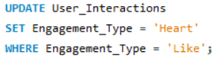

• This query updates the Engagement_Type column in the User_Interactions table.
• It replaces all occurrences of "Like" with "Heart" to align with Instagram’s terminology.
• The WHERE clause ensures that only rows containing "Like" are updated, preventing unnecessary changes to other values.
• To verify the changes, we can use the following query:
SELECT * FROM User_Interactions;
• This helps in confirming that all "Like" values have been successfully updated to "Heart".

